Record management features in PACS in relation to Working with Children Checks, Criminal History Record Checks (Police Checks) and Training
There have been significant changes in Victoria in relation to the safeguarding children, young people and vulnerable persons since PACS was first produced in the mid-2000s. While the developers have introduced features to manage volunteer and employee records relating to Working with Children Checks (WWCC), Criminal History Record Checks (Police Checks) and training over the past few years, the documentation has not been updated to reflect best practice. This information is intended to provide guidance for parishes in relation to creating and maintaining accurate records
The Victorian Child Safe Standards and recommendations from the Royal Commission into Institutional Responses to Child Sexual Abuse reflected in the National Principles for Child Safe Organisations highlight the importance of keeping records that demonstrate that appropriate due diligence is undertaken in relation to those engaged in ministry or work.
The creation and maintenance of accurate records and sound record keeping practices support accountability in relation to our commitment to safety of children, young people and people experiencing vulnerability. Retaining records also helps to protect those engaged in ministry or work within our parishes.
Some key principles
The overriding principles when handling data relating to clergy, volunteers and employees are to ensure that you keep accurate records, stored in a secure manner and never delete any records which may be required years into the future that may relate to promoting safety e.g. WWCCS, Police Checks, training records.
In short, don’t delete or overwrite any records or details which will show that the parish undertook its due diligence at the time the member of the clergy, employee or volunteer was involved in the parish.
For example:
- Rather than delete, Archive a family or member when they leave the parish.
- Untick Active if the person is no longer involved in a ministry, and make sure both start and end dates are recorded accurately. Even if you don’t know the start date, it’s still important to record the end date.
- Don’t overwrite former WWCCs, Police Checks or training records with new ones, without ensuring first that you have saved a record of the previous check in a note.

Private tab on the Member or Staff record
Recording WWCCs, Police Check and Training Information
Information in relation to WWCCS, Police Checks and training is recorded for employees and volunteers on the Private tab to ensure access to this information can be restricted in PACS security settings.
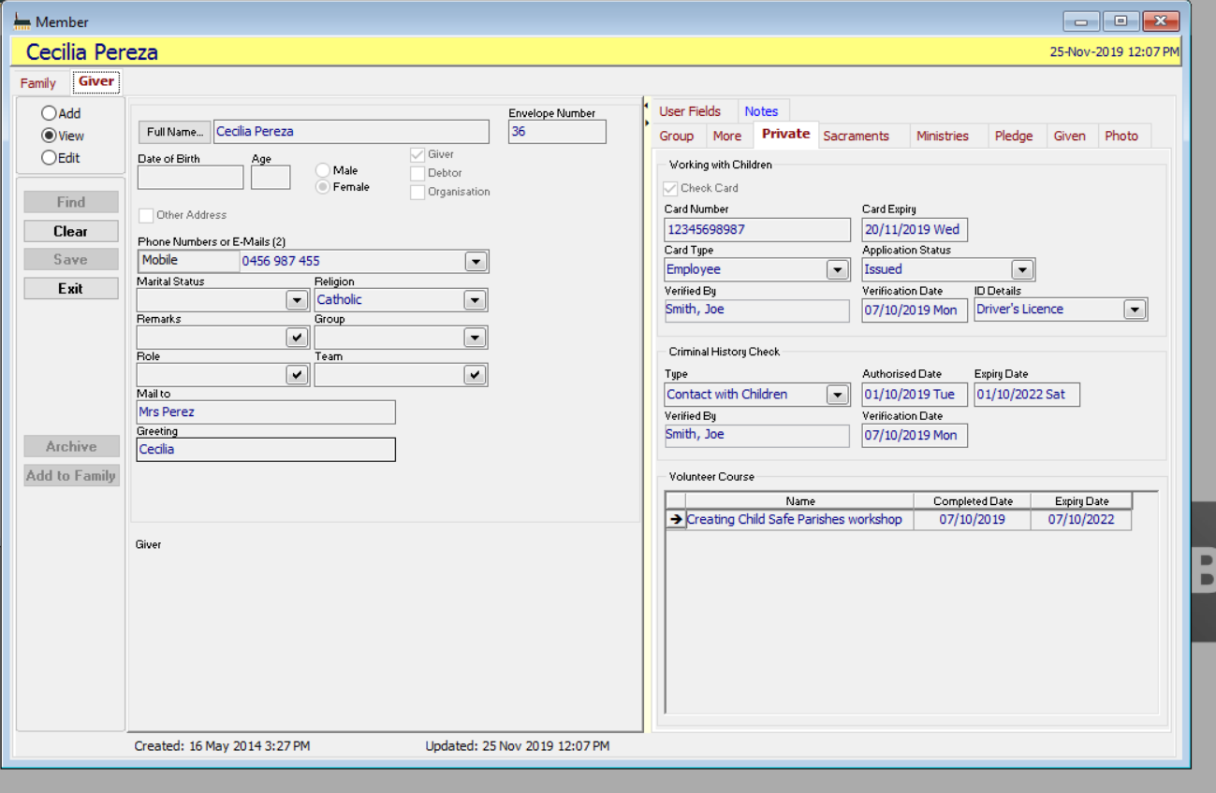
Working with Children
- Card number, taken from the card or letter from the Department of Justice. Renewed cards have -01, -02 etc after the original number. Make sure that you transfer expiry date, card type and verification details for the previous check into a note before updating this information for a renewed check. Enter Registration number here if the card type is a VIT Membership
- Card expiry, taken from the card or letter, or the VIT check site: https://www.vit.vic.edu.au/search-the-register
- Card type – select from the drop down list. Note that it can change with renewals if the volunteer’s employment circumstances change. Select VIT Registration for registered teachers without a WWCC (If it’s not on the list, right click>Edit>Add)
- Application status: Pending or Issued. The first time you submit an application, most of these fields will be blank until the check has been issued, but in the meanwhile, mark it as Pending.
- Verified By – drop down list of staff members, to record who verified the check. If a staff member is not on the list, right click>Edit>Add their details
- Verification Date - date the staff member verified the check
- ID Details – the document sighted by the staff member to confirm the person’s identity

Criminal History Check
Criminal History Check Type – if you haven’t already, right click>Edit>Add and enter the types of check required as list options, including VIT Registration. Relevant options from Victoria Police’s Consent to Check and Release National Police Record Application Form are:
- Contact with Children
- Adult Aged/Disabled Care and
- Other – e.g. Counters, Finance Committee
If the person is involved in a number of ministries requiring different types of check, Contact with Children should be selected in the drop down box, and details for the Contact with Children check entered on the Private tab (this screen). This check will appear on your Criminal History Check reports.
If they have any additional checks (e.g.: Counters), enter details on the Notes tab, [each in a separate] note. See Notes Tab section, below. Make sure you enter the expiry date as a follow up date, so that a Note - Follow Up Due Date reminder will come up 7 days before it’s due to expire.
- Criminal History Check Authorised Date - date on check/certificate, or initial VIT Registration Date for a teacher.
- Expiry Date – expiry date of check: add 3 years to the authorised date, according to the CAM PSU guidelines, or enter VIT Registration expiry
- Verified By – drop down list of staff members, to record who verified the check. If a staff member is not on the list, right click>Edit>Add their details
- Verification Date - date the staff member verified the check

Volunteer Course (Training)
Any number of courses can be entered as required with details of the Name of the course, Completed Date and Expiry Date.
The Name of course is entered as text, and is the only required field. Some courses don’t expire, so you can leave that field blank.
If a course has been repeated, keep details of earlier completions: don’t delete or overwrite details.
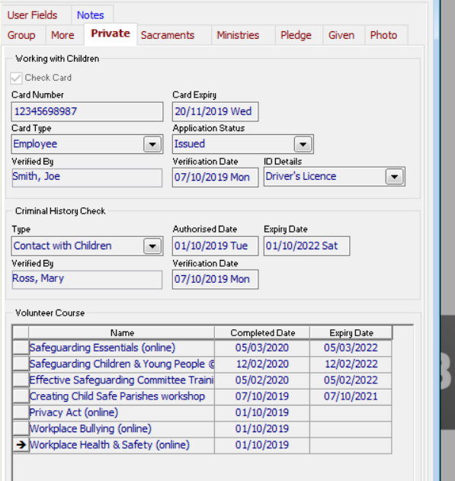

When a parishioner withdraws from one or more parish ministries, leaves the parish or is deceased
- Untick Check Card on the Private tab if they are no longer involved in any parish ministries.
- Go to the Ministries tab. enter an End Date and untick Active for each ministry, then Save. Do not select the ministry “row” and hit the delete key.

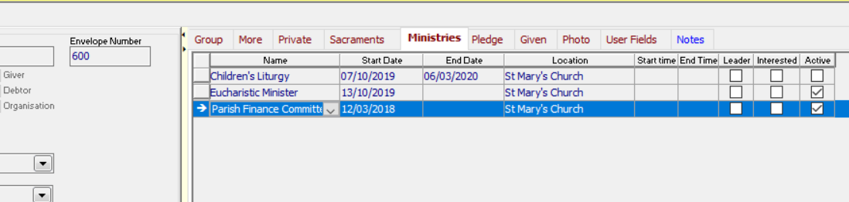

- You can do the same thing from the People>Ministries screen. However, regardless of what the PACS documentation or training notes say, do not click on Remove to delete them from the ministry! Even if a Ministry is discontinued in your parish, follow this for each volunteer listed in that ministry: never click on Remove All.
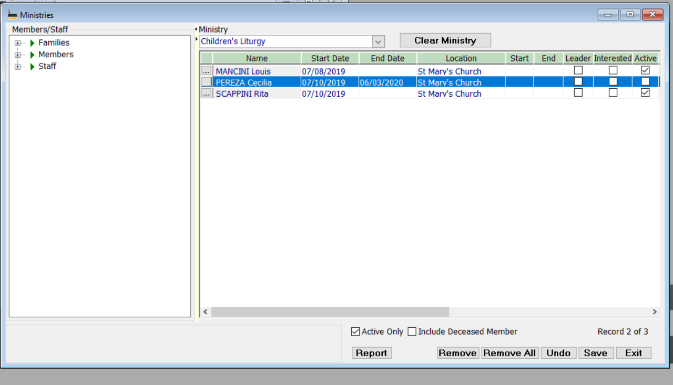

Photo tab
Adding photos
It is possible to add a photo of the person’s latest WWCC to their record, but if you want to retain it, keep a copy in a note (see next section). You can only have ONE photo added to a person’s record: you will lose the previous photo as you add a new one. Photos on the Photo tab or in Notes must be located on the T: drive, or other Parish staff will not be able to see them.
Notes tab
Adding documents to a volunteer record
Refer to Quick Answer (QA) 9. Using notes in PACS and QA 98. How to add attachments in PACS
Set up a Child Safety Notes category. Click on Security to block access to the Delete button for Child Safety Notes for all other users but ADMIN.
If you have not already done so, set up SMS and Email note categories, so that when you tick Record as Note in the SMS Centre and Email Centre, the message or email is saved in Notes. Unless the appropriate categories are set up, they’ll be saved, but can’t be viewed.
Set up a Child Safety folder on your T: drive to store documents and images. You can create a note either with or without content, and a Link to a document stored on your T: drive. If you store the document elsewhere, other Parish Staff will not be able to view it.
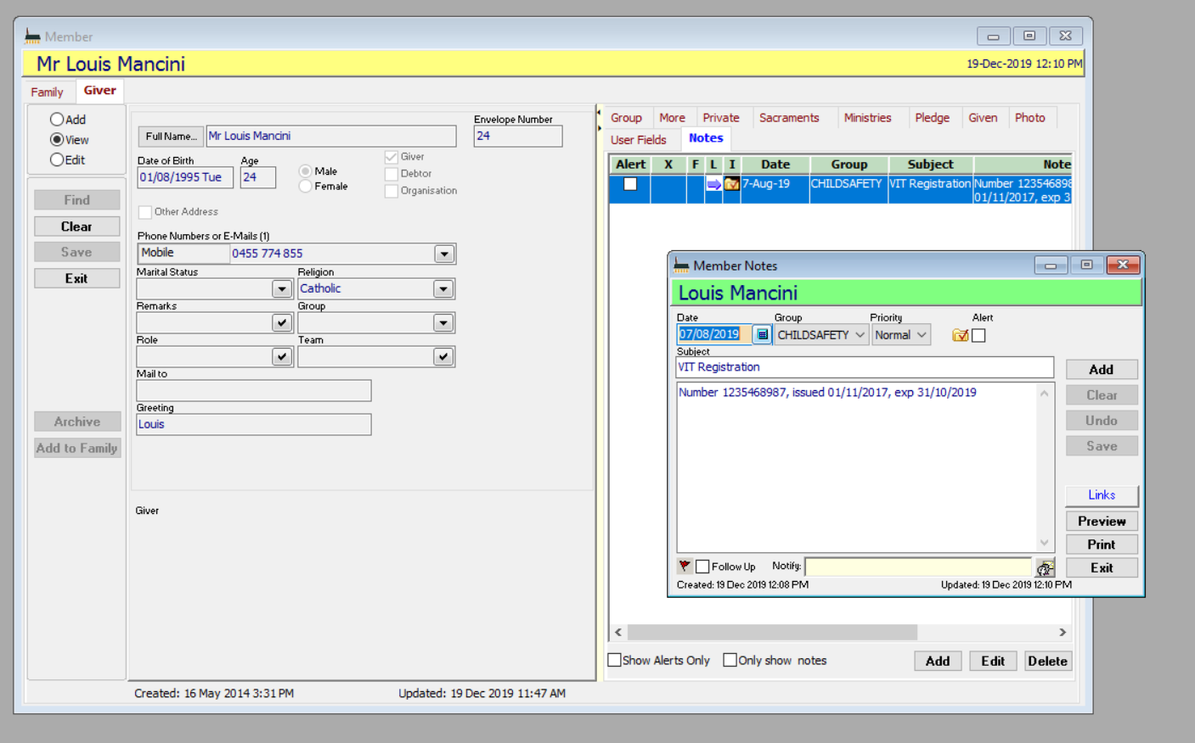

I’ve added a sample image from the T:\Training Account\PACS Child Safety documents folder
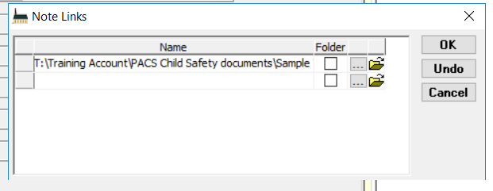

To open the link from the notes tab, click on the purple arrow. You don’t need to open the note.
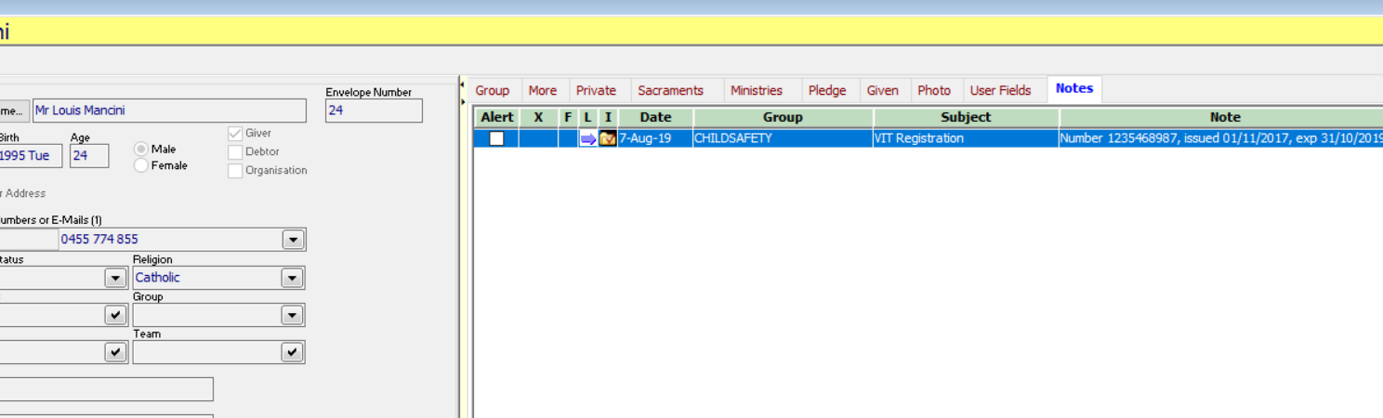

Reports and Exports
These are 2 almost identical REPORTS which list most of the information you will need in relation to WWCCs and Criminal History Checks.
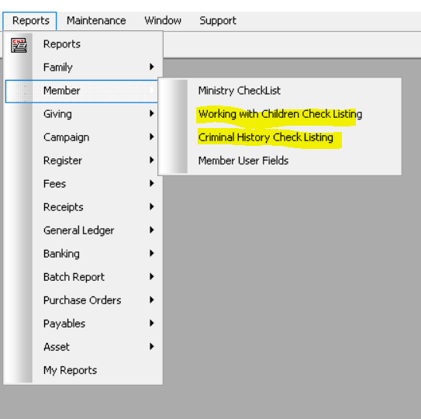
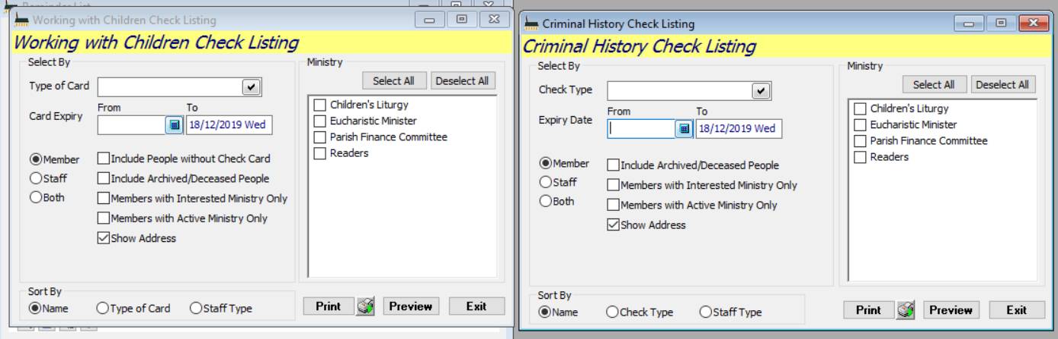
For a list of expired or expiring checks, leave the Expiry Date From field blank. To include all people in selected ministries, whether or not their Check has expired, delete the Expiry Date To field data.

To EXPORT data to an Excel spreadsheet, or for a mail merge, go to
People>Export>Ministry Export
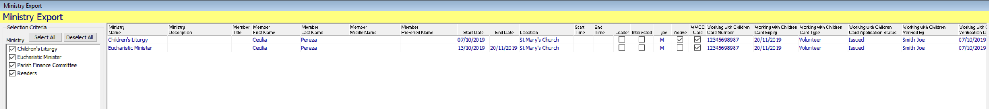
OR People>Export>Enhanced Export>Member folder
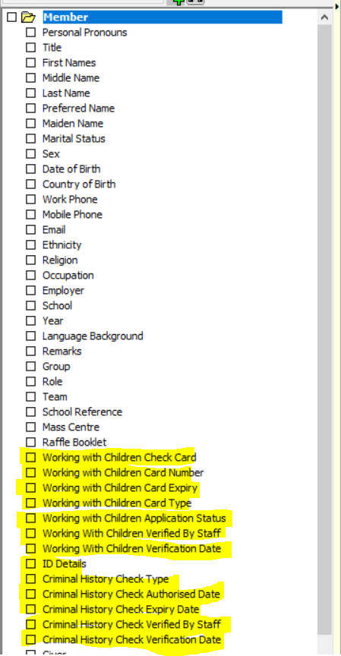

OR People>Export>Enhanced Export>Volunteer Course folder
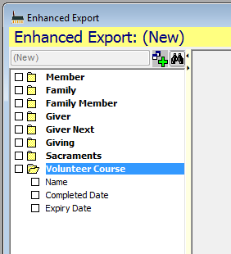

Reminders
Go to Maintenance> Setup> Reminder Dates> Available Events to set up reminders. Click and drag from Available Events at the bottom of the screen to Selected Dates, and then set an Activation Interval of 30 days for expiry dates, and 7 days for Note – Follow Up Due Date
• Member - Criminal History Check Expiry Date
• Staff - Criminal History Check Expiry Date
- Member – Working with Children Card Expiry Date
- Staff – Working with Children Card Expiry Date
- Note – Follow Up Due Date
- For all of these events, ensure that you tick Keep Reminding After Event Date. It’s extremely important that you are still reminded after the expiry date if the check hasn’t been updated.
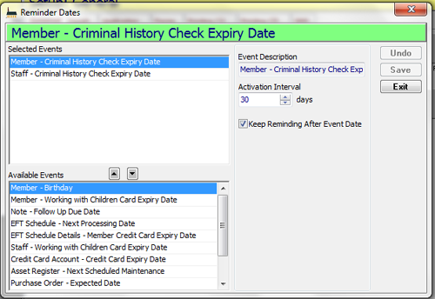

This is what the reminder looks like:
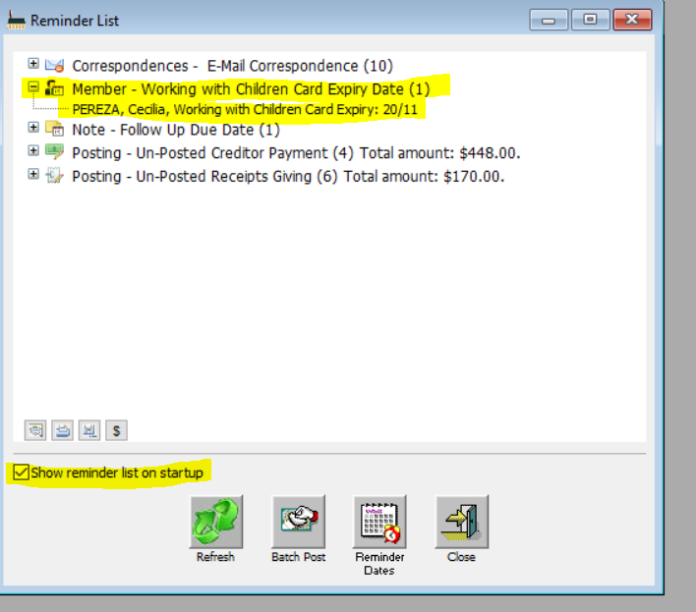
Tick Show reminder list on startup. Any other time you want to open the Reminder list, go to Maintenance>Reminder List.

Useful documents on Secureshare
On your POL desktop, click on the Online Help link, or go to https://secureshare.org.au/OLH, enter your POL username and password, and click on Quick Answers.
QA 006. Working with Children Check guide – food for thought about why and how you would handle non-parishioners’ child safety data
QA 009. Using notes in PACS
QA 98. How to add attachments in PACS
QA 106. How to save emails & SMS as notes in PACS
QA 111. Working with Children Check report
PACS Installation Guide (pages 34-42 Setting up security for PACS User accounts)
PACS Family & Members User Guide (pages 70-77 Using Notes)
Enter an Email address per login in PACS (particularly useful for directing replies to SMS and emails sent by the Child Safety Officer)

