TEMPLATE
Purpose
The purpose of this tool is to assist parishes or entities within the Catholic Archdiocese of Melbourne to self–assess their compliance with the Catholic Archdiocese of Melbourne Safeguarding Children and Young People Framework to ensure that child safety is embedded within the culture of the parish or entity and is reflected in the way in which the parish or entity conducts its ministry.
This self-assessment tool also enables parishes or entities through their Safeguarding Committees to document their progress in relation to creating safe environments for children and young people and to facilitate their readiness to be audited by the Victorian Government Commission for Children and Young People (CCYP) and / or Australian Catholic Safeguarding Limited (ACSL).
About the Self–Assessment Tool
This self-assessment tool is based on the CCYP Victorian Child Safe Standards (VCSS), specifically Standard 1 Organisations establish a culturally safe environment in which the diverse and unique identities and experiences of Aboriginal children and young people are respected and valued. The criteria noted for Standard 1 reflect the foundation steps for this standard identified by CCYP. In 2023, a further revision of this self-assessment tool will be forthcoming in response to material to be released by CCYP.
This self-assessment tool is in addition to the current Parish or Entity Child Safety Assessment Tool.
The Victorian CSS are mandatory for organisations in accordance with the Child Wellbeing and Safety Act 2005.
This self-assessment tool is also based on the ACSL Self-Assessment of Compliance which reflects the requirements of the National Catholic Safeguarding Standards. These are represented underneath each Criteria e.g. NCCS 1.1
The ACSL National Catholic Safeguarding Standards are aligned with the National Principles for Child Safe Organisations.
The Self-Assessment Tool is a MS Word document and is designed to be printed on A3-size paper. If you have any questions, please contact the Safeguarding Unit on 9926 5621 or email safeguardingunit@cam.org.au

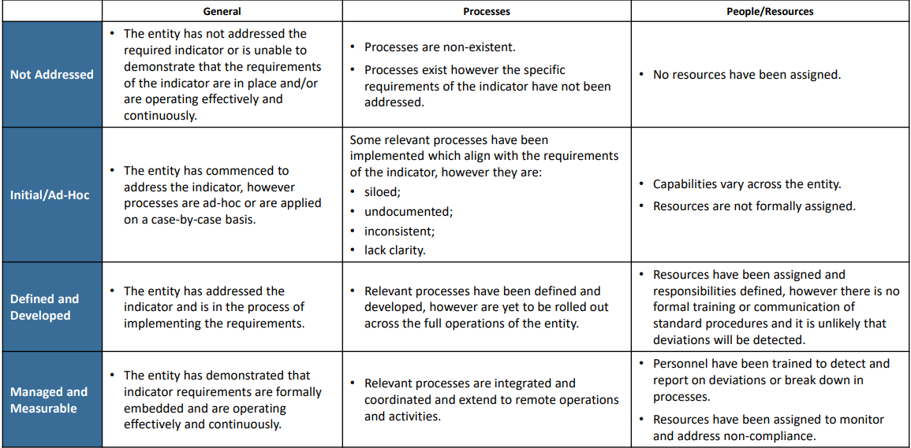
How to use the Self–Assessment Tool

The Parish or Entity Self-Assessment Tool requires parishes or entities to assess themselves against each indicator, using the Compliance Assessment Scale developed by ACSL.

In addition, for each indicator, the following questions will need to be answered:
      - What is already in place? What evidence do we have of this?
- What more do we need to do?
- Who is responsible? What is the timeframe?

Answers for each questions should be comprehensive and include any activities that are in progress, planned or not implemented.

Please note: If your parish or entity believes an indicator is Not Applicable, please provide an explanation.

Relevant resources that may assist your parish or entity in meeting the requirements of each indicator are listed at the end of each section. These resources are also available on the Safeguarding Framework and Resources section of the Catholic Archdiocese of Melbourne website: https://melbournecatholic.org/
If you require any further information or assistance, please contact the Safeguarding Unit on 9926 5621 or via email safeguardingunit@cam.org.au.

Standard 1: Parishes and entities establish a culturally safe environment in which the diverse and unique identities and experiences of Aboriginal children and young people are respected and valued.
Criteria | Indicator requirements | Not Applicable | Not addressed | Initial / Ad Hoc | Defined & Developed | Managed & Measurable | What is already in place?  What evidence do we have of this? | What more do we need to do? | Who is responsible?  What is the timeframe?
Criteria 1.1  A child’s ability to express their cultural rights is encouraged and actively supported.  (NCSS 1.1, 4.1, 4.2, 4.3, 5.1) | A public commitment to the cultural safety of Aboriginal children is available and displayed for public access.
 | Personnel must encourage and support children to express their culture and enjoy their cultural rights.
The Code of Conduct and position descriptions outline behavioural expectations of all personnel including:
zero tolerance of racism and expectations that personnel will act to prevent and report incidences of racism.

Criteria 1.2  Strategies are embedded within the parish or entity, that equip all personnel and members of the community  to acknowledge and appreciate the strengths of Aboriginal culture and understand its importance to the wellbeing and safety of Aboriginal children and young people.  (NCSS 4.1, 4.2, 4.3, 5.3, 7.4, 10.5) | Personnel are strongly encouraged to actively support and facilitate the inclusion and participation of Aboriginal children and their families within the parish or entity.
 | The parish or entity identifies steps already taken to guide or train personnel and leaders to understand, respect and value Aboriginal culture and to understand the importance of this to the wellbeing and safety of Aboriginal children
 | The parish or entity identifies steps already taken to recognise and celebrate Aboriginal peoples, their achievements, communities and cultures.
Criteria 1.3  Measures are adopted by the parish or entity to ensure racism within the parish or entity is identified, confronted and not tolerated. Any instances of racism are addressed with appropriate consequences.  (NCSS 4.1, 4.2, 4.3) | The Safeguarding and Wellbeing of Children and Young People Policy, describe the parish or entity’s commitment to respecting and valuing Aboriginal children, whilst addressing how racism will not be tolerated and how instances of racism will be responded to, including potential consequences.
 | The Code of Conduct and position descriptions outline behavioural expectations of all personnel, including that children will be supported to express their culture and enjoy their cultural rights.
 | The parish or entity identifies steps already taken to ensure racism within the parish or entity are consistently identified and appropriately addressed.
Criteria 1.4  The parish or entity actively supports and facilitates participation and inclusion within it by Aboriginal children, young people and their families.  (NCSS 1.2, 4.1, 4.2, 4.3, 10.3) | A public commitment to the cultural safety of Aboriginal children is available and displayed for public access.
 | The parish or entity leadership helps all personnel and members of the community, to acknowledge and appreciate the strengths of Aboriginal culture and understand its importance to the wellbeing and safety of Aboriginal children.
 | The parish or entity identifies steps already taken to actively support and facilitate participation and inclusion of Aboriginal children and their families
Criteria 1.5  All of the parish or entity’s policies, procedures, systems and processes collectively create a culturally safe and inclusive environment and meet the needs of Aboriginal children, young people and their families. (NCSS 1.4, 4.1, 4.2, 4.3, 10.1) | A public commitment to the cultural safety of Aboriginal children is available and displayed for public access.
 | Policies and procedures relating to child safety and wellbeing, including the Child Safety and Wellbeing Policy, describe the parish or entity’s commitment to respecting and valuing Aboriginal children.
 | The parish or entity identifies steps already taken to create a culturally safe environment for Aboriginal children.

Resources that may help your parish or entity meet Standard 1:
INFORMATION SHEET: Promoting the Safety of Aboriginal and Torres Strait Islander Children and Young People
INFORMATION SHEET: Promoting the Safety of Children and Young People from Culturally and Linguistically Diverse (CALD) Backgrounds
Safeguarding Children and Young People Policy
TEMPLATE: Safeguarding Children and Young People Policy – please locate the template on this webpage
INFORMATION SHEET: Parish, Agencies and Entity Commitment to the Safety of Children and Young People
TEMPLATE: Parish, Agency and Entity Statement of Commitment to the Safety of Children and Young People - please locate the template on this webpage
INFORMATION SHEET: Parish, agency and entity safeguarding responsibilities
Safeguarding Children and Young People Code of Conduct and Declaration
TEMPLATE: Safeguarding Children and Young People Code of Conduct and Declaration – please locate the template on this webpage
INFORMATION SHEET: Empowering children and young people
INFORMATION SHEET: Encouraging the Participation of Children and Young People in Decision-making
INFORMATION SHEET: Consulting with Children and Young People
Role description templates can be located on this webpage

National Catholic Safeguarding Standards; Edition 1 2019 Self-Assessment of Compliance https://www.cpsltd.org.au/media/1438/cpsl-self-assessment-of-compliance-all-stds-may-2019.pdf

